距离标定计算脚本使用说明
Instructions

- 确认标定上下界
Verify the calibration upper and lower bounds
- 获取能量数据方式
Method of obtaining energy data
- 获取能量数据
Getting energy data
- 生成TAU文件
Generating TAU files

FalconDLP APP实现FalconDLP Solution ：
1、确认标定上下界Verify the calibration upper and lower bounds
打开文件1-transmittance.xlsx。确定需要标定的距离和环境温度的上下界。如下图1所示。
Open file 1-transmittance.xlsx. Determine the upper and lower bounds of the distance and ambient temperature to be calibrated. See Figure 1 below.
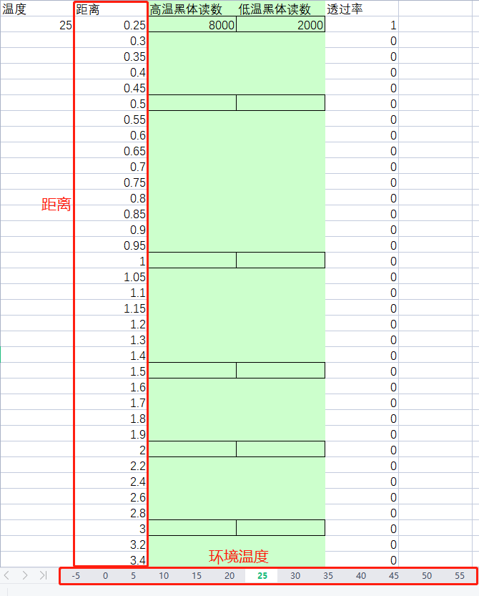
图1 距离与环境温度
2、获取能量数据方式Getting energy data
打开FalconDLP，图2所示，未出图时不可用。（操作详见《FalconDLP使用说明》）
When FalconDLP is opened, as shown in Figure 2. (See FalconDLP Instructions for operation)
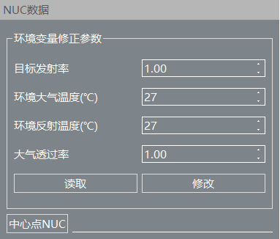
图2 中心点能量数据
- 修改：输入四项环境变量的数值，并点击“修改”按钮。
Modify: Input the values of the four Ambient variables and click the "Modify" button.
环境大气温度Default value of ambient temperature: 27°C
环境反射温度Default value of reflected temperature: 27°C
发射率Default value of emissivity: 1.0
大气透过率Default value of atmospheric transmittance: 1.0
（2）中心点能量值：点击“中心点能量值”即可进行中心点的能量值的计算，采集能量数据前，打快门。若图像中未显示中心点十字光标以及温度数据，此时会自动勾选“显示中心点温度”。
Center point energy value: Click "Center point energy value" to calculate the energy value of the center point, and press the FFC before collecting energy data. If the center point cross cursor and temperature data are not displayed in the image, "Show center point temperature" will be automatically selected.
3、获取能量数据Getting energy data
分别采集当前环境温度下模组距离高温黑体和低温黑体一定距离时，读出对应的黑体中心点能量值，记录到表格1-transmittance.xlsx对应位置（建议高增益下高低黑体温度设为20℃与120℃，低增益下高低温黑体温度设为100℃与400℃；建议距离0.25米、0.5米、1米、1.5米、2米、3米、4米和5米，可以根据使用需求扩大或者缩小测量范围或者更换除0.25米以外所有距离点）；
When the module is a certain distance from the high and low blackbody at the current ambient temperature, respectively, read the energy value of the corresponding blackbody center point and record the corresponding position in Table 1-transmittance.xlsx (it is recommended that the high and low blackbody temperatures are set to 20℃ and 120℃ for high gain, and the high and low blackbody temperatures are set to 100℃ and 400℃ for low gain; The recommended distance is 0.25 m, 0.5 m, 1 m, 1.5 m, 2 m, 3 m, 4 m and 5 m, and the measuring range can be expanded or reduced according to the use requirements or all distance points except 0.25 m can be replaced);
确保每一个环境温度下对应的表中、测量距离对应的区间内都填入至少2组高低温数值。
Ensure that at least two groups of high and low temperature values are filled in the table corresponding to each ambient temperature and in the interval corresponding to the measurement distance.
4、生成TAU文件Generating TAU files
用matlab打开transmittance2tau1.m,确认文件名与对应表格一致
Open the transmittance2tau1.m file with Matlab and verify that the file name is consistent with the corresponding table
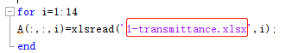
点击matlab程序上方“编辑器”，点击“运行”按钮，运行完成后即可获得SDK所需Tau.bin。
Click the "Editor" at the top of matlab program, click the "Run" button, and you can get the Tau.bin required by SDK after running.
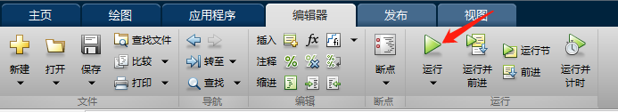
注：1-transmittance.xlsx内数据缺省，透过率显示0均正常，无须测量所有值。
Note: 1-transmittance. XLSX data loss, transmittance display 0 is normal, there is no need to measure all values.

SDK实现SDK Solution：
1、确认标定上下界Verify the calibration upper and lower bounds
打开文件1-transmittance.xlsx。确定需要标定的距离和环境温度的上下界。如下图1所示。
Open file 1-transmittance.xlsx. Determine the upper and lower bounds of the distance and ambient temperature to be calibrated. See Figure 1 below.
图1 距离与环境温度
2、获取能量数据方式Getting energy data
获取能量函数Function：
- 调用函数read_nuc_parameter，读取模组中的测温参数，为测温修正提供测温映射数据；
The function read_nuc_parameter is called to read the temperature measurement parameters in the module and provide temperature mapping data for temperature measurement correction.
- 调用函数calculate_org_env_cali_parameter，读取模组中的内置环境变量参数并进行相关系数计算；
Call the function calculate_org_env_cali_parameter, read the built-in ambient variable parameters in the module and calculate the correlation coefficient;
- 调用函数reverse_calc_NUC_with_nuc_t计算环境变量修正后的能量数据；
Call the function reverse_calc_NUC_with_nuc_t to calculate the energy data corrected by the ambient variable;
- 调用函数reverse_calc_NUC_without_env_correct计算环境变量修正前的能量数据，采集数据前打快门；
Call the function reverse_calc_NUC_without_env_correct to calculate the energy data before ambient variables correction and carry out the FFC before data collection;
3、获取能量数据Getting energy data
分别采集当前环境温度下模组距离高温黑体和低温黑体一定距离时，读出对应的黑体中心点能量值，记录到表格1-transmittance.xlsx对应位置（建议高增益下高低黑体温度设为20℃与120℃，低增益下高低温黑体温度设为100℃与400℃；建议距离0.25米、0.5米、1米、1.5米、2米、3米、4米和5米，可以根据使用需求扩大或者缩小测量范围或者更换除0.25米以外所有距离点）；
When the module is a certain distance from the high and low blackbody at the current ambient temperature, respectively, read the energy value of the corresponding blackbody center point and record the corresponding position in Table 1-transmittance.xlsx (it is recommended that the high and low blackbody temperatures are set to 20℃ and 120℃ for high gain, and the high and low blackbody temperatures are set to 100℃ and 400℃ for low gain; The recommended distance is 0.25 m, 0.5 m, 1 m, 1.5 m, 2 m, 3 m, 4 m and 5 m, and the measuring range can be expanded or reduced according to the use requirements or all distance points except 0.25 m can be replaced);
确保每一个环境温度下对应的表中、测量距离对应的区间内都填入至少2组高低温数值。
Ensure that at least two groups of high and low temperature values are filled in the table corresponding to each ambient temperature and in the interval corresponding to the measurement distance.
4、生成TAU文件Generating TAU files
用matlab打开transmittance2tau1.m,确认文件名与对应表格一致
Open the transmittance2tau1.m file with Matlab and verify that the file name is consistent with the corresponding table
点击matlab程序上方“编辑器”，点击“运行”按钮，运行完成后即可获得SDK所需Tau.bin。
Click the "Editor" at the top of matlab program, click the "Run" button, and you can get the Tau.bin required by SDK after running.
注：1-transmittance.xlsx内数据缺省，透过率显示0均正常，无须测量所有值。
Note: 1-transmittance.xlsx data loss, transmittance display 0 is normal, there is no need to measure all values.

